March 8, 2016 Meeting Summary

Aim to build a prototype MRV system for rangelands in the northern Great Plains that includes carbon flux and belowground carbon stocks. This is needed to fill key gaps in our knowledge of rangeland carbon in the CMS and to support a REDD+ program for grassland ecosystems.
Approach will be to build and validate carbon models at a 36,000 ha research area, where PI’s have been investigating carbon and developing AGC models using Landsat since 2010. This core research area will be used to apply NASA data and data products and to downscale current 250m weekly flux data (EROS), while concurrently building BGC datasets needed to ultimately predict BGC using carbon flux-driven models.
This first stage of rangeland carbon MRV development will be used as a model to expand into other NGP rangelands, which comprise most of the land area for North and South Dakota.
We have 3 models: 1) historical site potential
2) MODIS NEP
3) Landsat AGC and BGC
Will we find a convergence among these models spatially?
If not, what then?
Is the Landsat model our best estimate of truth?
Which of the two MODIS models would be expected to be more reliable?
Can we just downscale MODIS NEP and assess convergence with Landsat model?
What is our justification for the historical site potential if we have flux? Bruce?

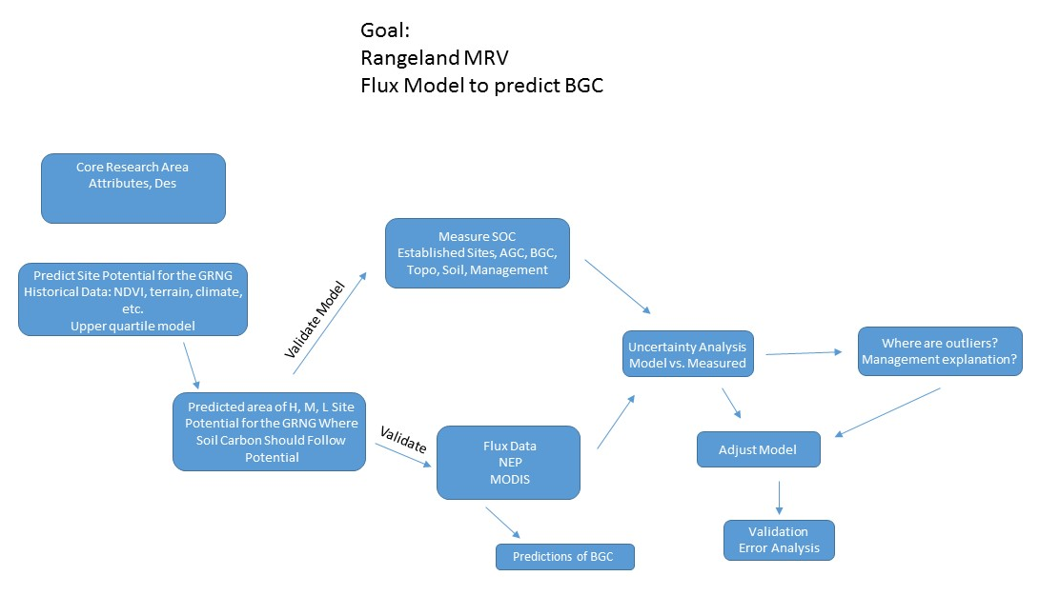

March 9 2016
Some contemplative thoughts from this morning's van pool ride to work:

1) Hypothesis: Expect good relationship between long-term grassland soil carbon and long-term grassland NEP because:
a) perennial grass store most of their carbon below ground.
b) off take of C from the site is less with livestock grazing than crop harvest
- livestock return a fair portion of consumed C as fecal matter (I am ignoring methane belching here)
2) Grassland soil carbon stocks may become vulnerable to emission in a warming (and drying?) system

WYLIE PERSPECTIVE
- Soil organic Carbon (SOC) is the main parameter of interest (30m; from Phillips + Elevation + landsat?).
- Secondary variables for convergence of evidence (peak biomass vs SOC; long term NEP vs SOC) or outlier (management) identification
Comments by Rebecca in blue, Wylie in yellow
Peak Biomass
- MODIS (250m) NDVI weekly time series back to 2000
  - Identify 2000-2015 upper quartile mean NDVI at each week and average across growing season (April through Sept—yes, but canopy is green only from May to 15 Sep) = Peak Weekly Growing season NDVI (PWN)==proxy for biomass (Gu et al. 2014)
  - Predict PWN from long term static environmental variables using regression tree modeling at 250m (helps remove management effects and allows downscaling to 30m)
    - Elevation
    - CTI or other landscape position variables from DEM
    - Slope for north facing slopes (within an aspect range) above a minimum slope, else assigned 0 (aspect only relevant for steeper slopes) Done at 30m. NEED TO FIGURE OUT HOW TO SCALE THIS TO 250M FROM 30M. our plots are on south facing slopes. Can we take the polygons of topographic position, which integrate continuous areas of toeslope, etc. and weight these data for a variable into a modis pixel?
    - Slope for south facing slopes (within an aspect range) above a minimum slope, else assigned 0 (aspect only relevant for steeper slopes) Done at 30m. NEED TO FIGURE OUT HOW TO SCALE THIS TO 250M FROM 30M. can we just use our polygons instead of using slope data? See clip below from our paper.
    - Climate (30 year?) Precipitation and temperature (I assume annual means or total, but open to ideas of growing season only??) Have at 800m resolution, use bilinear interpolation to get to 250m, then bilinear to get to 30. ASSUME MINOR LOCAL ELEVATION GRAIENT EFFECTS ON PRECIPITATION Yes (orographic lifting and rain shadows)
    - Soils (have SSURGO available waterhoding capacity and soil organic C rasterized to 30m, but unsure that this will have the detail we need @ 30m; regression tree will only use it if it aids prediction) We could measure these at field plots.
    - Other variables?? MLRA’s? LandFire Environmental Site Potential (http://www.landfire.gov/NationalProductDescriptions19.php) but a categorical variable (only used by regression tree to stratify) with lots of catagories? Landfire Biophysical settings –includes historic disturbance (http://www.landfire.gov/NationalProductDescriptions20.php) Not sure about this…Brad? We could get fire history as well as grazing.

From phillips et al 2012
    - 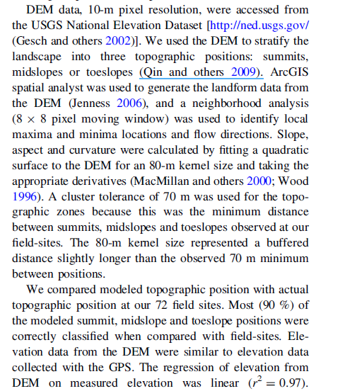

  - Apply mapping regression tree model to 30m inputs to predict 30m PWN (downscaling approach of Gu and Wylie (2015a,b)
  - Convert to grass biomass (Gu et al 2014), which could be compared to our biomass with Landsat….
- Use NEP scaled up from flux towers and averaged across 2000-2008 at 250m (Wylie et al. submitted) to get upper quartile mean weekly NEP through the growing season and sum that or average it (average is OK if the growing season time is held constant) = Peak NEP (PNEP) (MAYBE JUST THE INTERANNUAL AVERAGE NEP IS ENOUGH? WORRIEDUPPER QUARTILE WEEKLY FLUX NOT REALISTIC?)Perhaps look at the range of PNEP as compared to the range of total standing crop? We have 3 images in autumn with biomass predicted and measured, but at this time the SWIR was a better predictor. After mid Sept, the greenness indices fall short. Do you want to consider PNEP between May and mid Sept, when plants are mostly green? We have two images, 2010, 2011 in July at peak standing crop. Would these data be more related to PWN and PNEP?
  - Use regression tree at 250m using same inputs as above at 250m to predict PNEP
  - Use the regression tree model to map at 30m using 30m inputs.

Assess convergence of evidence between 30m SOC & peak biomass @ 30
- Outliers theoretically would be management effects.
- If relationship is week then look at 250m relationship (is it a downscaling error or true biological miss-match?)
Repeat above with SOC & NEP and NEP & peak biomass…
Run regression tree (to predict SOC) or decision tree (to predict SOC classes) from climate, elevation, etc. OR from peak biomass & NEP.
Also think of an ordination approach (non dimensional scaling??) to look at:
- Biomass predictors
- NEP predictors
- SOC, NPP, Biomass

